***Course No: SWE 430***

***Information and Network Security Lab***

**Assignment on**

**Lab 6: Securing Apache Web Server - 2**

**Submitted To:**

Partha Protim Paul

Lecturer, IICT, SUST

**Submitted By:**

Promi Mojumder

Reg No: 2019831038

IICT, SUST

**Lab 6: Securing Apache Web Server – 2**

**Task – 1:**

1. **Enable the mod_rewrite module using a2enmod command.**

1. **Look at the /etc/apache2/sites-enabled directory to find the configuration file for port 80 for example.com**

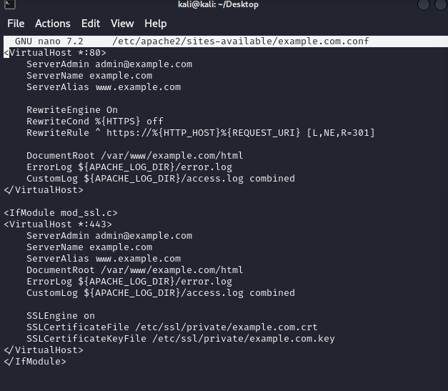

1. **Testing Apache configuration and restart the Apache server.**

1. **Testing example.com on your browser. It’ll show “Hello, World!”**



**Task-2:**

1. **Adding users to Apache web server using the following command:**

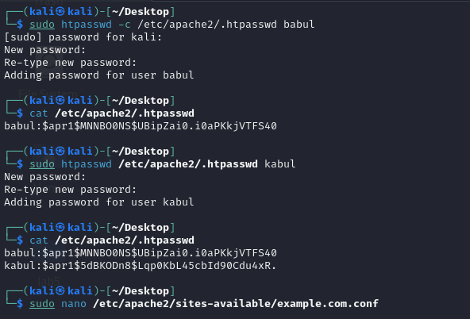

1. **Use the following command to cat the contents of .htpasswd file.**



1. **Adding a few lines into https configuration file for example.com.**



1. **Restarting the apache server.**
2. **When accessing to example.com, it’ll show a prompt to give username and password.**

1. **Now providing the username and password from before created.**

1. **Now, I can access the site.**

**Task-3:**

1. **Installing and configuring Mariadb server on kali linux.**

1. **Creating a database called ‘apache’ and use the following command to use the apache database.**

1. **Creating a table called users**

1. **Instead of storing plain passwords in database, use the following command to create a hashed password for users named Sammy and Alice in a separate consoleA screenshot of a computer program

   Description automatically generated**
2. **Now store the hashed password**

1. **Enable the mod_authn_dbd module of Apache and modifying configuration file’s contents.**

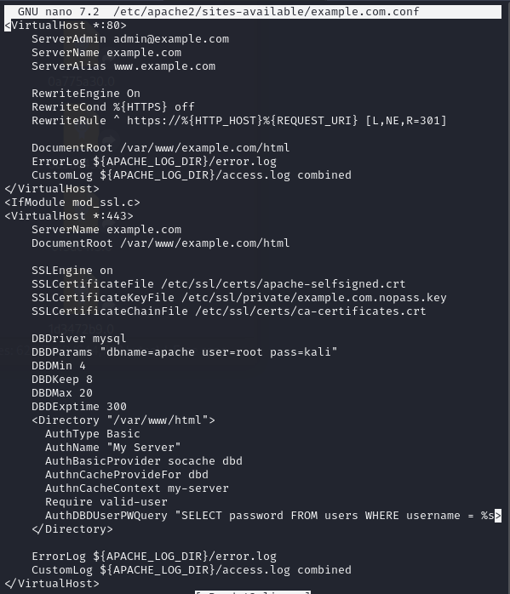

1. **Restart the Apache server.**
2. **When accessing the example.com page, it’ll show a prompt for username/password. Providing the one that have in your MySQL database. Now you can access the page.**

